Operating System - System Documentation

The Danner
Dave
Craig

Introduction

Welcome to the Monstah Operating System guide. Here we will take a deep look at the mechanics, principles and ideas of that help make up the Monstah Operating System or MOS for short. MOS is comprised of a two basic pieces. First we have the simulated CPU and its associated components. The other half is an input file, which itself is comprised of control, program and data cards.

CPU Structure

The CPU in the MOS is simulated. By that we mean, it does not physically exist, but our program simulates the behaviors of a collective of pieces that emulate a real machine, albeit a very basic one. In the picture below we show the basic components that we are attempting to duplicate via means of software.

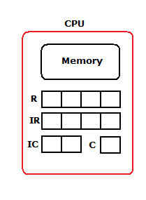
Memory – a 100 x 4 array of 4 byte words that is shared by both program and data cards.

R – which is short for General Purpose Register, is controlled by the user through several commands listed later

IR – Instruction Register is used by the MOS load the next instruction specified by the address in IC and is then executed by MOS

IC – Instruction counter that will tell the MOS the address of the next instruction

C – A small one byte register used to store a 0/1 toggle later used in branching.

SI – (not shown on diagram) is an additional register used just by the MOS for various interrupts.

Memory –

As shown below, memory is a simple array of 100 total words, where each word is separated into 4 bytes. Memory is show here as a 10 x 10 x 4 array because there are several procedures where an entire line, or 10 words, 40 bytes are read in at any given time.

For example consider GD60, this command will take the next line from the data field of the program, and place all 10 words from there into memory locations 60 through 69. PD60 would according print from lines 60, through 69. When program cards are read in when the MOS is initially loading a program, it will read an entire line at a time an place each line, or card in memory 10 words at a time sequentially.

This is not always the behavior however. LR64 for example, will access just the 4 bytes at location 64 and place them in the general purpose register.
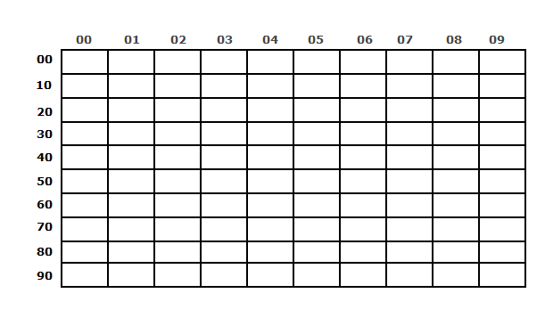

General Purpose Register –

The general purpose register, GPR, or R for short is a register that is available to the user for a few uses such as filling with information and or placing information in memory elsewhere. GPR is 4 bytes long to match any given word in memory. If a command comes in, LR64 for example, the content in memory at 64 will be placed in corresponding bytes in the GPR.

Instruction Register –

Access to this register is only available to the MOS. During the standard fetch, increment, execute cycle this register will be loaded with whatever is existing at memory location in the instruction counter. This will need to be one of the seven valid commands available to the user or an error will result.

Compare Register –

A very small register designed to hold a 1 or 0 that is set by using the CR command. This register can only be set by the MOS and not by the user. It is set by CR and read by BT commands.

Instruction Counter –

At the heart of the MOS is the instruction counter. This 2 byte register is vailable to the user in a non direct way but mostly controlled through the MOS. When execution of commands begin, the first instruction will be read from the address that resides in the IC. When the instruction has been executed the IC is incremented so that the next sequential instruction will be loaded into the IR and the cycle repeats. If a branch statement from the user program is ever read, and the condition associated with it reads true, the address next to the BT command will be overwritten in whatever the current IC has so that execution now “jumps” to where the user wishes the control of execution to go.

Input File

The input file, and correct formatting of it, is essential to the MOS executing programs properly. Each program needs to be listed in immediate succession of the previous program, no breaks are allowed. Each program must consist of three control card statements, at least one program card and usually, but not necessarily one or more data cards.

Control Commands

$JOB –

This control command must be specified in each program. It tells the MOS that it is at a new program. To go along with this command, $JOB must be followed by a sequence of numbers that MOS will also use to determine certain aspects about the program. There must exist a string of 12 numbers, each broken down into 4 numeric numbers.

The first set of 4 relates to the program’s name, ie 0015 would be program number 15. Program numbers do not need to be in any kind of order, but they do need to be unique.

The middle 4 numbers are a time counter. To prevent a user error and having MOS run endless loops, there exists a counter that a user specifies to indicate the maximum number of instructions that MOS should attempt to execute before it must exit. If a value of 0083 is given, a maximum of 83 instructions will be ran before MOS will terminate.

The last group of 4 is a print limit counter. Like the time limit, it exists solely to prevent users from creating endless printing loops. If the last set of 4 numbers were to read 0003 only 3 lines could be printed before MOS will terminate.

All together the opening line can be very cryptic but it is important never the less that a user properly fills it out. As a final example consider the entire line

$JOB042501820032

Here we can see that we have a new program, named 0425, it can execute a maximum of 182 instructions and print a total of 32 lines to terminate properly.

Program Cards

Once the header line has been read and the system variables for execution and print limits has been set, MOS will read the next ensuing lines as program cards until it reaches the nxt control card delimiter. Program cards are read 10 4-byte words at a time. They are placed at memory location 0 through 9. If there are more than 1 program cards, each card will be read into the MOS memory at similarly increasing memory locations. So program card 2 will be read into memory location 10 through 19, card 3 will be read into locations 20 through 29 and so on. This incrementing is handled automatically by the MOS and the user cannot control where program cards are placed.

$DTA

MOS cannot tell what is a program card, or a data card, or anything for that matter. It relies upon the control commands to tell it what’s next. Accordingly, once MOS has started reading program cards, it will continue to do so until it comes across this command. At this point the MOS will read this line in and it will signify that all program cards have been entered, and execution of the program should commence. It is also a marker to let MOS know that any future lines are either data cards, used and accessed by the program, or the $EOJ command to end the program.

Data Cards

While not required, most programs will follow the $DTA command with data cards. These are used by the user to bring input into the MOS. They are read 40 bytes at a time into a location specified by the GD command which is explained further in this manual. Data cards are vital to creating useful programs for the user but the MOS does not need to handle them until called for and if no GD is ever used

$EOJ

This command will be followed by a sequence of 4 numeric numbers which should match the program number specified by the $JOB tag. Upon reaching this line MOS will know to it ahs reached the end of the program and will either load the next program or terminate the simulation.

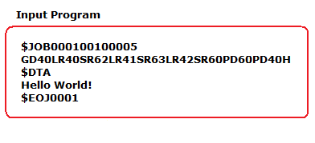

Shown above is a sample program. From what has been described so far we can see that this program had a number 1, it should run no more than 10 instructions, and print no more than 5 lines. It has one program card that starts with GD40 and it also has one data card “Hello World!”. The ending tag matches up with the opening one and this will end up running our basic hello world program successfully.
Program Commands

Thus far all that has been discussed are the internals of the CPU and some basic formatting of the input file. To make a program and be useful, the user must understand how program commands work, and the MOS must interpret them correctly. When MOS begins executing any given program it will expect to encounter one of 7 commands or throw an error.

The commands are handled in different areas of the MOS. Because Input, output and exiting a program are must more taxing operations then the simpler load, store and compare commands MOS handles the commands in different ways. A “slave” mode is used to handle most of the commands while interrupts are set for others.

Slave Mode:

Slave mode is the simulation of program instructions that have to deal with memory access and execution. Input and output procedures are left for the master mode to handle. Only instructions relating to registers are handled here.

Get Data – GDXX

Description: Get data command is a way for the user to read in data cards that they have placed. MOS reads the first two characters to determine that this is a get data command and then use the address associated with the instruction to determine where to place the next line of data in memory. The last number will be dropped and a 0 placed in its place, and all 40 bytes of the next data card are read into 40 bytes in memory, in that respect GD53, GD59 and GD50 are all exactly the same as they will all load the next data card in memory locations 50 through 59.

Consider a program that has GD54 as the next instruction and the data card “Hello World!” as the next data card. MOS will drop the 4 and essentially make the command GD50. It will then load “Hell” into location 50, “0 Wo” into 51 and “rld!” into location 52.

Slave Mode Operation: Si = 1

Print Data – PDXX

Description: Similar to get data, print data will drop the last numeric value in the address, set to 0, and then access all 40 bytes at a time. Instead of gathering information though, PD will print that 40 byte stream onto the screen and an output file.

Slave Mode Operation: Si = 2

Halt – H

Description: Halt command tells MOS that the program is done executing and it can terminate.

Slave Mode operation: SI = 3

Load Register – LRXX

Description: Load Register will take the content at the specified memory location and place it in the general purpose register

Slave Mode Operation: R <- M[IR[3,4]]

Store Register – SRXX

Description: Store register takes the content of the GPR and places those bytes are the given word address. It is the logical inverse of LR.

Slave Mode Operation: R -> M[IR[3,4]]

Compare Register – CRXX

Description: Compare register will look at the content of the GPR and compare that against the value of the memory location specified. If the two are equal, the compare register will be set to true.
Slave Mode Operation: Compare R and M[IR[3,4]], if equal C = T else C = F

Branch To – BTXX

Description: If the compare register is set to true, the IC should be set to the address specified and execution will then take place form that point, else the command is skipped.

Slave Mode Operation: If C = T, then IC <-IR[3,4] else skip

Master Mode:

The MOS is responsible for many other functions then just handing a few commands in a program. The system must handle input and output, and interrupts that may have been raised. Additionally many housekeeping activities are done in the master mode such as clearing out registers and memory between programs, handling the different program ID numbers, incrementing instruction and print counters and also handling their logical checks to determine in a program needs to terminate or not.

During execution the Si interrupt can be raised at any time and the Master Mode will ne called to help handle the instruction. Based on the Value of SI, MOS will handle the procedure accordingly.

Service Interrupt –

Service interrupt is a register used internally by MOS for special cases where the slave mode cannot handle a certain operation in an attempt to simplify what the slave mode should be doing.

SI = 1
When Si has been set to one MOS will know that it needs to perform a get data routine. It will go to the input file, get the next line of data, and place it in memory at the given address in the instruction register.

SI = 2
This will tell the MOS that there needs to be a print from the memory location starting at IR[2]0 and going until IR[2]9.

SI = 3
Set by the Halt command this tells MOS to stop executing the program and either terminate simulation or load the next program.

